WHO-UMC CAUSALITY ASSESSMENT SCALE:
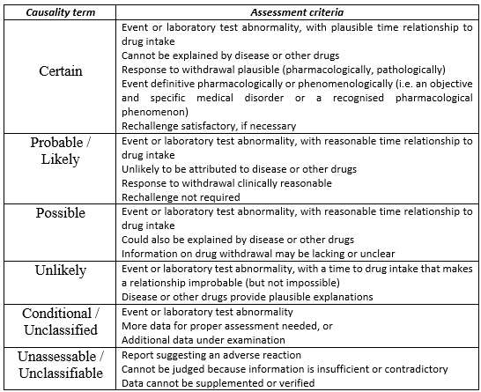
NARANJO ALORITHM:
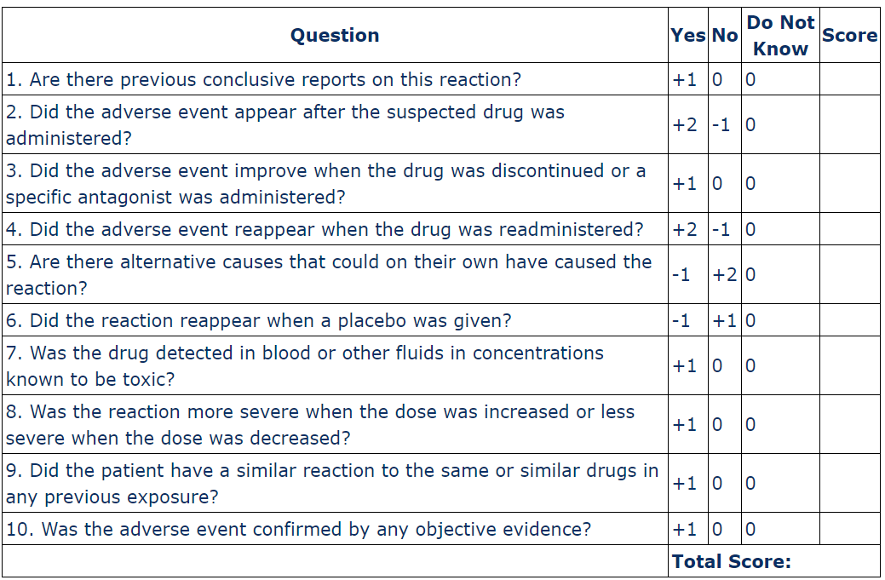
CASE SCENARIO:
Patient: Mrs. R, 56-year-old female, 68 kg
Medical history: Hypertension, type 2 diabetes, and dyslipidemia. No known drug allergies or previous angioedema.
Suspected drug: Enalapril 10 mg orally once daily.
ADR identified: After approximately 3 months of enalapril therapy, the patient developed sudden swelling of the lips, tongue, and face, accompanied by difficulty swallowing and mild difficulty breathing. No rash, itching, recent food allergy, or insect bite was reported.
Assessment: The reaction is likely drug-related because angioedema is a recognized adverse effect associated with ACE inhibitors. The timing of the reaction and absence of an obvious alternative cause support enalapril as the suspected drug.
Management: Enalapril was immediately discontinued. The patient was monitored for airway obstruction and received IV corticosteroid and antihistamine treatment. Her symptoms improved within 24 hours, and enalapril was permanently discontinued.
Causality: Probable/Likely
Dechallenge: Positive
Rechallenge: Not performed
Seriousness: Serious, due to potential airway obstruction.
Outcome: Recovered.
Conclusion: The patient experienced probable enalapril-induced angioedema. Prompt recognition and discontinuation of enalapril resulted in recovery.
CAUSALITY ASSESSMENT:
